**Lab Assignment 4**

**Question 1**

Verilog Code

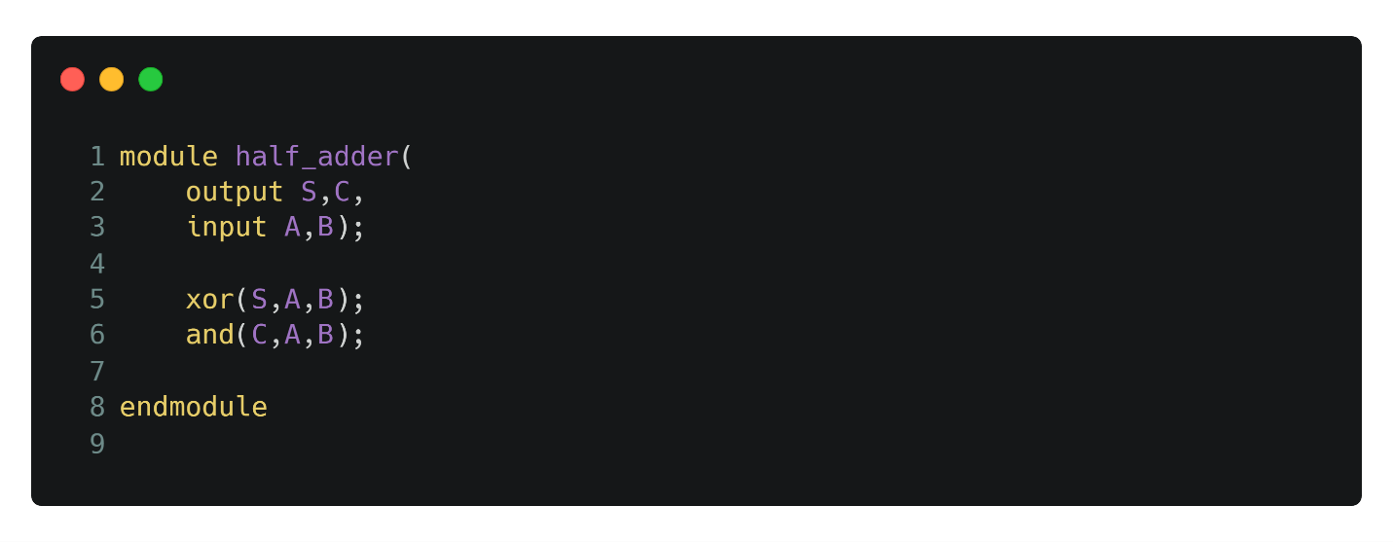

Quatrus Prime Waveform

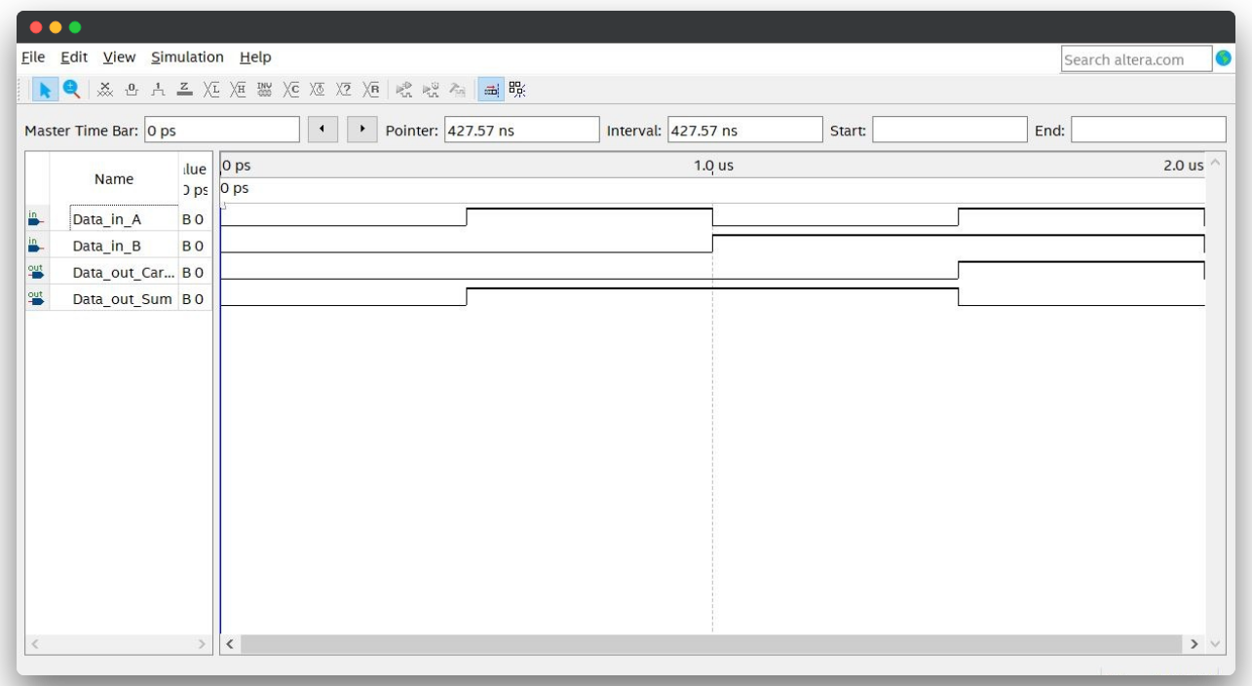

**Question 2**

Verilog Code

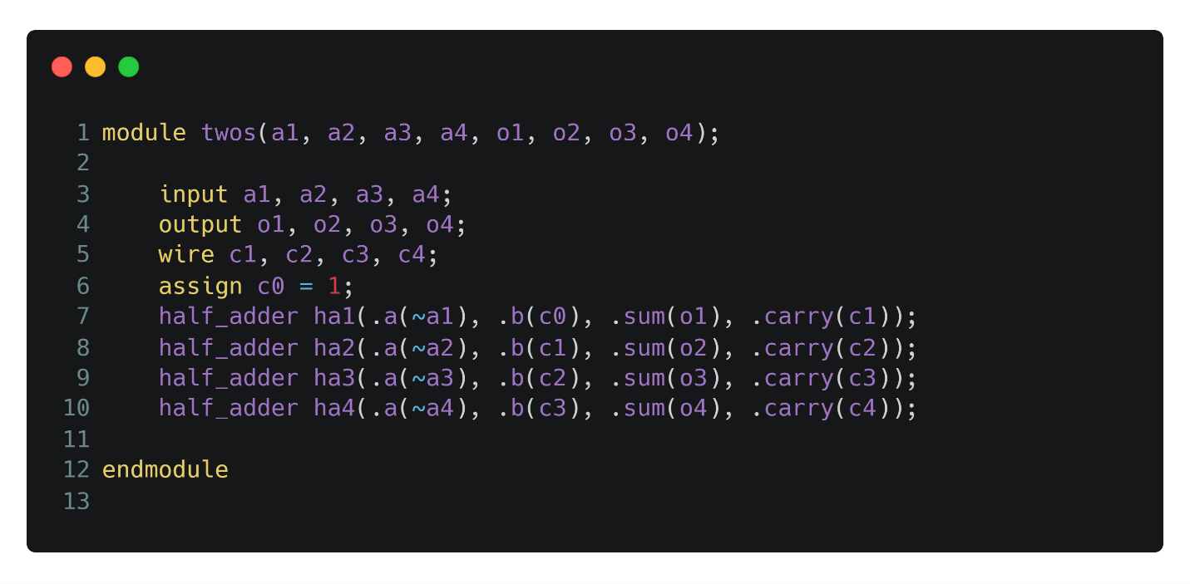

Quatrus Prime Waveform

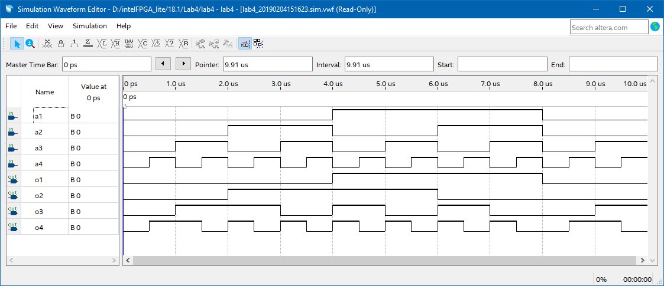

**Question 3**

Verilog Code

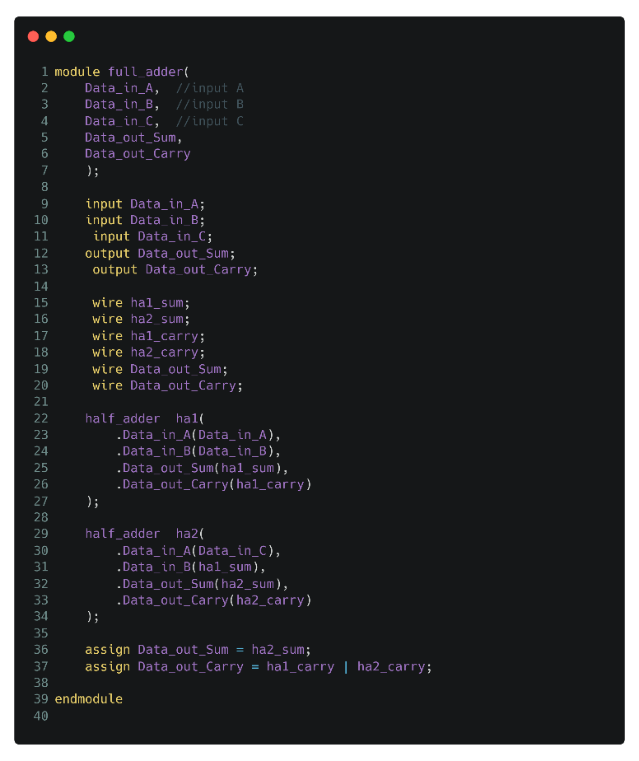

Quatrus Prime Waveform

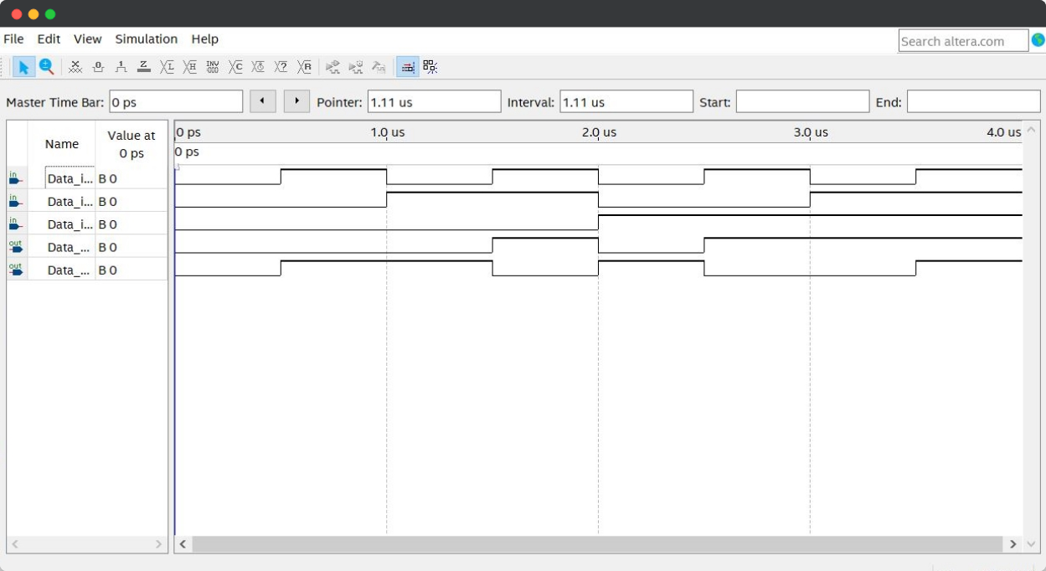

**Question 4**

Verilog Code

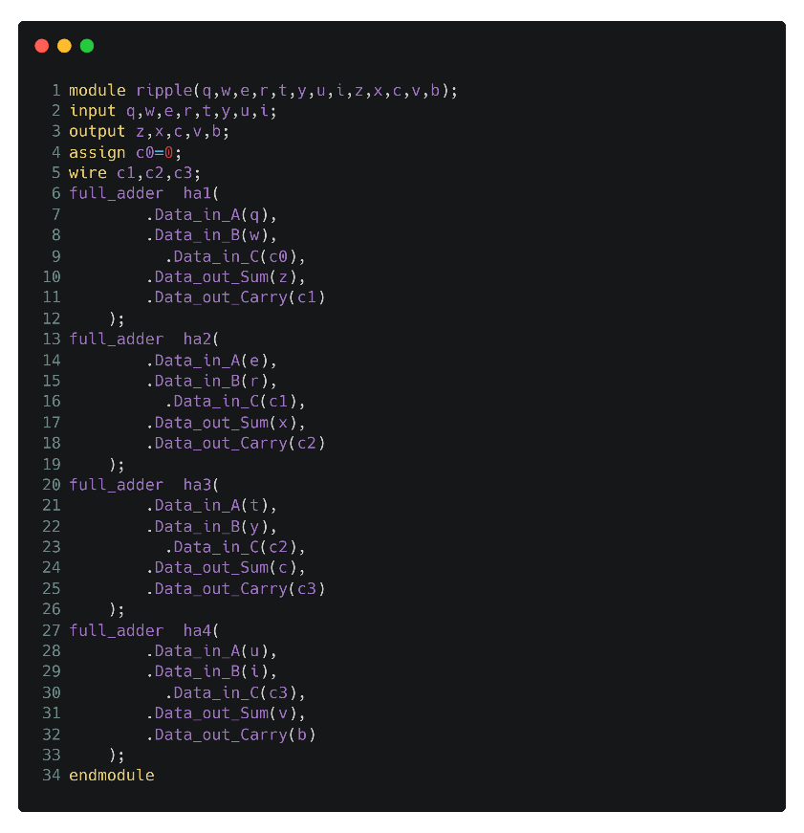

Quatrus Prime Waveform

